**DEAP dataset**

Here some subjects watched some videos wearing the EEG headset. After watching the videos subjects rated the videos in terms of valence (1-9), Arousal (1-9) and Dominance (1-9). Valance represents the positivity of the video. These three ratings can be used to represent almost all the emotions. You may want to take a look at the following 2D and 3D graphs for a clear understanding. But for this study, we only took valance into account. we divided the ratings into two parts. One is negative (1-4.99) and the other positive (5-9). So that this problem becomes a binary classification task.

One great difference between Confusion and DEAP dataset is that for recording confusion data only one EEG electrode was used but for DEAP 48 channels were used. So, it makes DEAP data more accurate as it captures activities from more regions of the brain.

For more detailed information, you can take a look at the DEAP website and their paper.

DEAP description: <http://www.eecs.qmul.ac.uk/mmv/datasets/deap/readme.html>

DEAP paper: <https://ieeexplore.ieee.org/document/5871728>

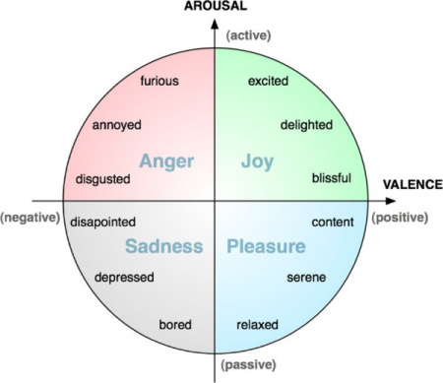

Img ref: <https://github.com/katedukhnai/valence-arousal-recognition>

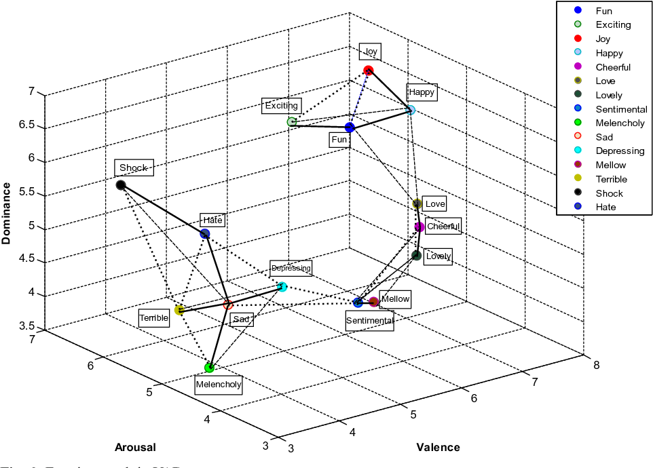

Img ref: <https://www.semanticscholar.org/paper/Affect-representation-and-recognition-in-3D-space-Verma-Tiwary/dfdfb8865773854d2837ce61249a927b5f270507/figure/8>